**Group 8- Cricbuzz**

Cricbuzz is a web application for getting updates regarding cricket. It includes live scores of a match to news regarding cricket all over the world. This application is a dynamic project where the scores are updated on real time basis.

The page is divided into multiple regions having navigation bar, live scores, news, videos and photos. This project can be achieved by using many technologies like Spring Boot, Angular, Spring REST and so on.

We have divided the project into many milestones having various stories in it. By doing this, we can calculate the average time taken and testing can be done easily.

# Milestone 1: Player Details

## Stories:

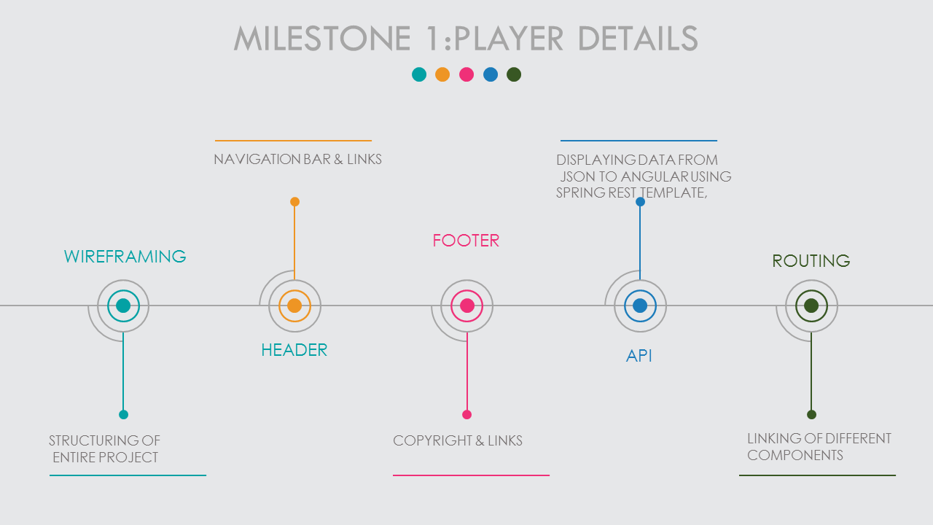

1. **Header-Templating**:

It will include logo, Home Page, Player Details, Upcoming Matches, News, Video, About Us tabs.

**Average time for completion** – 4 hours

1. **Header-Routing**:

Linking different components with each other and able to access each page.

**Average time for completion** – 3 hours

1. **Header-Video**:

Working on YouTube API to add videos of trending.

**Average time for completion** – 3 hours

1. **Header-News RSS**:

Working on Cricket RSS feed to add updated news in the news tab.

**Average time for completion** – 3 hours

1. **Footer**:

It will consist of copyright and support links.

**Average time for completion** – 3 hours

1. **API 1- Researching**:

Researching whether to use an API or MongoDB database.

**Average time for completion of first part-** 5 hours.

1. **API 1-Implementing-Angular**:

Implementing how to use angular to consume JSON.

**Average time for completion of first part-** 5 hours.

1. **API 1-Implementing-Spring Rest Template**:

Implementing how to use REST Template to consume JSON.

**Average time for completion of first part- 4** hours.

1. **API 1-Implementing-Jersey implementation**:

Implementing how to use Jersey to consume JSON.

**Average time for completion of first part- 4** hours.

1. **Implementing-MongoDB**:

Implementing player collection which provides info about the player.

**Average time for completion of first part- 3** hours.

1. **Implementing-MongoDB-Adding Images**:

Adding images in MongoDB.

**Average time for completion of first part- 3** hours.

1. **Spring Data MongoDB**:

Accessing the data from MongoDB in Spring Boot.

**Average time for completion of first part- 4** hours.

1. **Using Spring data with Angular**:

Displaying data from MongoDB into Angular.

**Average time for completion of first part- 4** hours.

1. **About Us**: Creating About Us page where all member details are explained.

**Average time for completion –** 3 hours.